https://www.quora.com/What-are-the-types-of-artificial-intelligence
https://www.edureka.co/blog/types-of-artificial-intelligence/

**********************************************************************************
What are the types of artificial intelligence?
Artificial intelligence is a technique that can be divided into many different types and we have classified it into two main types. It is based on a number of capabilities and is functionally based on the main AI and we have used the following flow diagram to explain the types of AI.
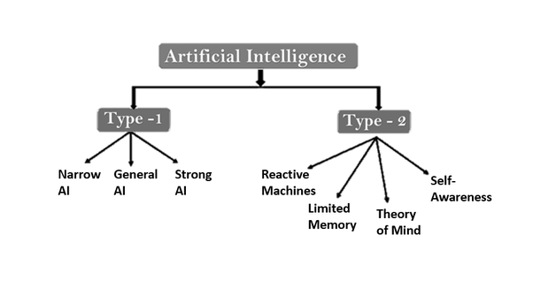
1
Type 1 - AI: Based on Capabilities
Narrow AI
- Narrow AI is an AI technology that enables the user to perform a variety of dedicated tasks with intelligence and is considered one of the most common and currently available AI technologies in the world.
- Narrow Eye is designed for a specific task, due to which it is able to function within its limits and for this Apple series is the best example of AI.
- According to experts, IBM's Watson supercomputer also works under Narrow Eye, it provides services like machine learning and natural language processing to the user.
General AI
- General AI is a technique that is considered to be a type of intelligence that performs any kind of intellectual work like a human.
- Today behind normal AI, a system has been created which is very clever and when the time comes, it can think like a human on its own.
- Today the general AI is focusing all the experts around the world to manufacture many developing machines.
- As you are seeing, many systems with common AI are under research and it will take a lot of effort and time to develop such technology.
Super AI
- Super AI is part of an intelligence of the system, with the help of which machines can surpass human intelligence and are able to complete any task better than humans.
- Super AI has included some special abilities such as other features like dialogue, reasoning, and puzzle-solving.
- Today Super AI is considered to be a kind of hypothetical concept of artificial intelligence which is actually still considered a world-changing task for developing such systems.
Type 2 - AI: Based on functionality
Reactive Machines
- Reactive machines are considered one of the best basic types of purely artificial intelligence.
- Basically it is used to focus on the present scenario, due to which the past experience cannot be stored.
- For example, you can take IBM's Deep Blue System and Google's AlphaGo.
Limited Memory
- Limited memory is a machine that can help store some data from past experiences for a short time.
- The important use of this machine is to use stored data for a limited time.
- As an example, if all self-driving cars are one of the best examples of a limited memory system then it stores all the data of the car.
Theory of Mind
- The theory of Mind AI is capable of many other social interactions like human emotions and beliefs.
- To date, no such AI machine has been made, but many researchers are trying to make such a machine.
Self-Awareness
- Self-awareness has been told by experts that this is completely the future of AI, which will be called Super Intelligent.
- This machine will be the smartest than the human mind.
- Self-awareness AI through researchers does not really exist yet but it is just its imaginary concept.

Branches Of Artifical Intelligence
Artificial Intelligence can be used to solve real-world problems by implementing the following processes/ techniques:
- Machine Learning
- Deep Learning
- Natural Language Processing
- Robotics
- Expert Systems
- Fuzzy Logic
Under Machine Learning there are three categories:
- Supervised Learning
- Unsupervised Learning
- Reinforcement Learning

Deep Learning
Deep Learning is the process of implementing Neural Networks on high dimensional data to gain insights and form solutions. Deep Learning is an advanced field of Machine Learning that can be used to solve more advanced problems.
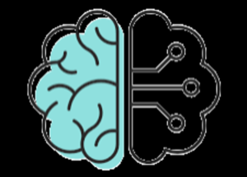
1

Deep Learning is the logic behind the face verification algorithm on Facebook, self-driving cars, virtual assistants like Siri, Alexa and so on.

Natural Language Processing
Natural Language Processing (NLP) refers to the science of drawing insights from natural human language in order to communicate with machines and grow businesses.
Twitter uses NLP to filter out terroristic language in their tweets, Amazon uses NLP to understand customer reviews and improve user experience.

Robotics
Robotics is a branch of Artificial Intelligence which focuses on different branches and application of robots. AI Robots are artificial agents acting in a real-world environment to produce results by taking accountable actions.
Sophia the humanoid is a good example of AI in robotics.

Fuzzy Logic
Fuzzy logic is a computing approach based on the principles of “degrees of truth” instead of the usual modern computer logic i.e. boolean in nature.
Fuzzy logic is used in the medical fields to solve complex problems that involve decision making. They are also used in automatic gearboxes, vehicle environment control and so on.

Expert Systems
An expert system is an AI-based computer system that learns and reciprocates the decision-making ability of a human expert.
Expert systems use if-then logical notations to solve complex problems. It does not rely on conventional procedural programming. Expert systems are mainly used in information management, medical facilities, loan analysis, virus detection and so on.
So with this, we come to an end of this Types Of Artificial Intelligence Blog. If you wish to learn more about Artificial Intelligence, you can give these blogs a read:

